**SBS Transit - Real time bus monitoring system tender**

**Solution write up and development**

# Mock UI Primary Design Discussion

# Bus Journey by Direction

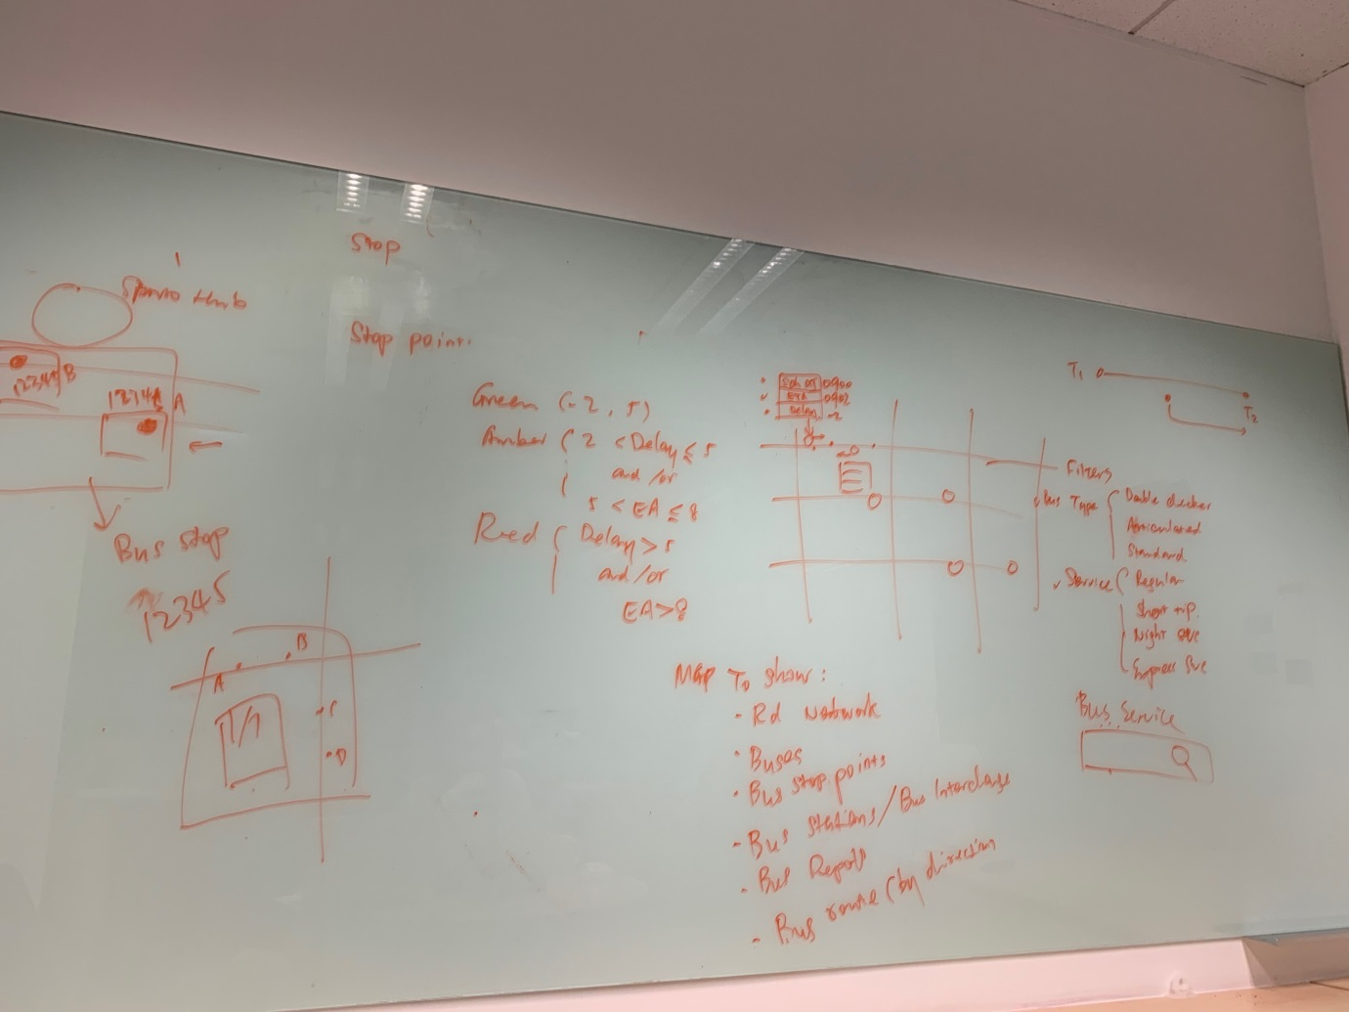

1. Each Bus has time detail

* Scheduled Arrival time
* Estimated time
* Delay time

1. Color display for arrival time
   1. Green (-2, 5)
   2. Amber (-2 < Delay < 5) and/or (5 < ET < 8)
   3. Red (Delay > 5) and/or (EA > 8)
2. Map has to show

* Road network
* Buses
* Bus stop Points
* Bus Interchange
* Bus Deport
* Bus Route (by direction)
* Bus Breakdown information
* Traffic Light Junctions
* Break the fleet distance
* Traffic condition

1. Filter by Bus Service, Bus Types
2. Bus Types

* Double ducker
* Articented
* Standard type

1. Bus Services

* Expressway Service
* Regular Service
* Short Trip Service
* Night Trip Service

# Graph - Passenger Boarding and Alighting

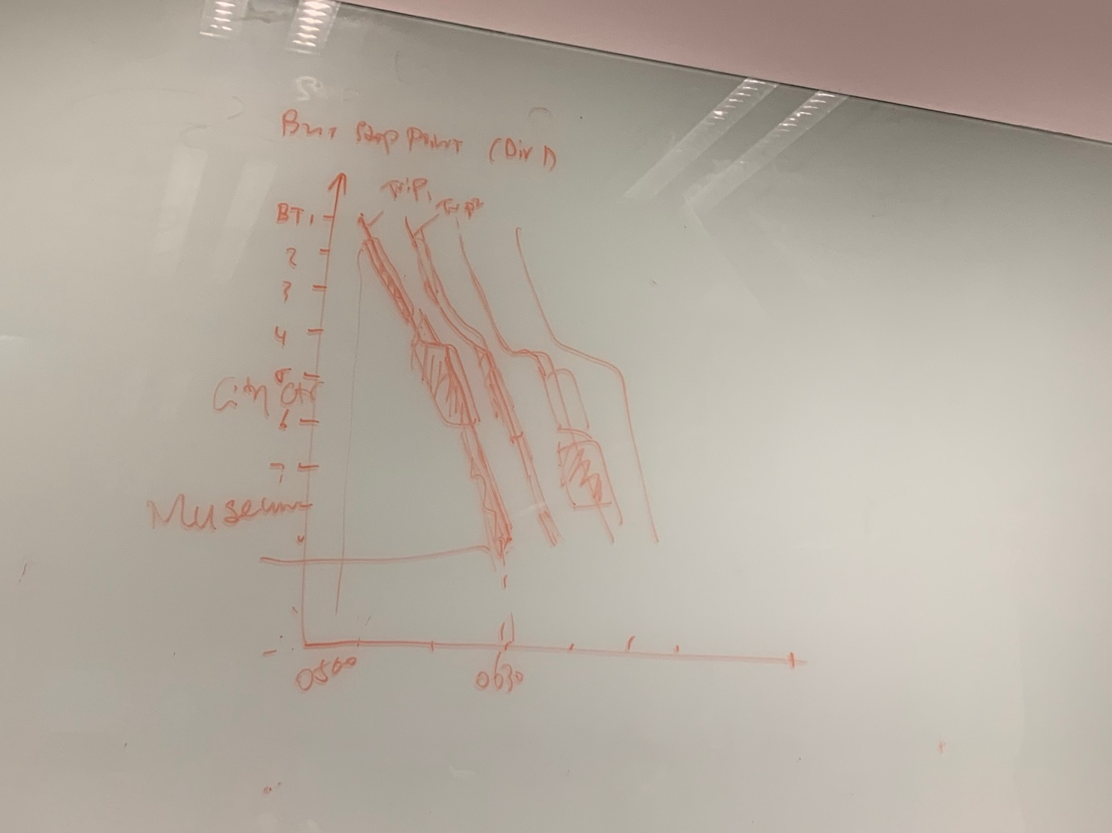

1. Filter by

* Service
* Direction

1. Passenger List

* Alighting
* Boarding

1. Graph list the following
   * Particular Trip information
   * More Passenger in a trip
   * More Services in hours

# Graph – Terminals by direction

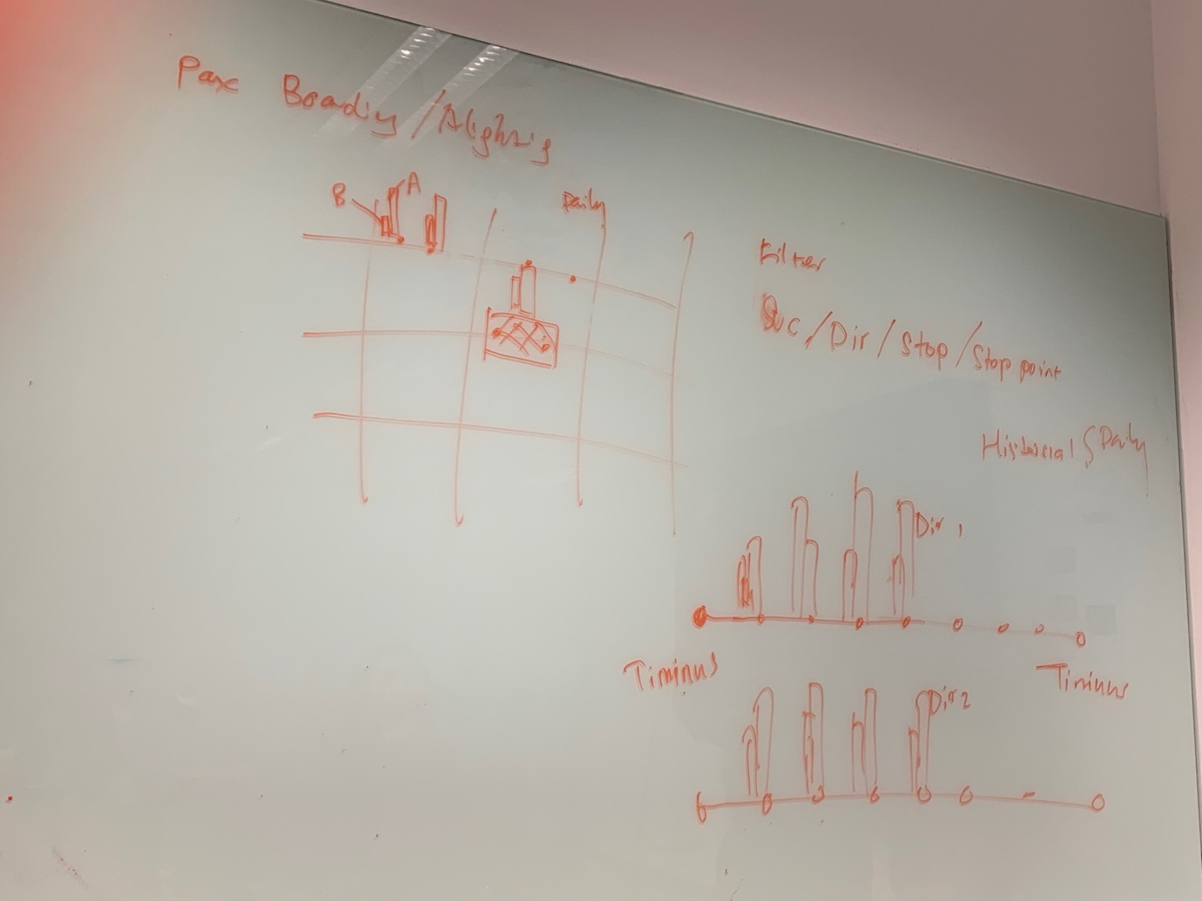

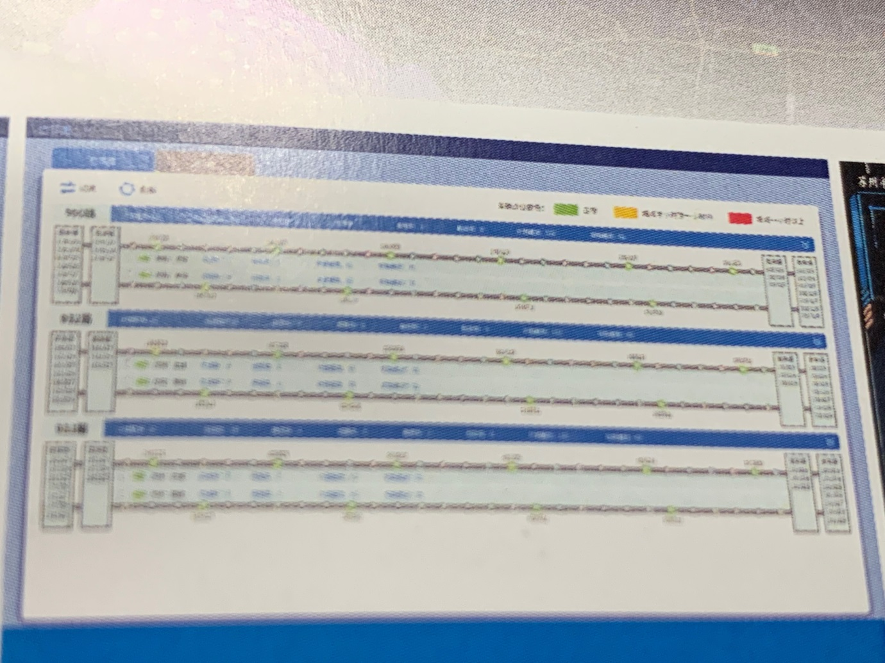

1. Daily List

* Alighting / Boarding
* Bus stops
* Arrival / estimated /delay Timing
* No of buses
* No of Buses meet the target time

# Bus Fleet Tracking

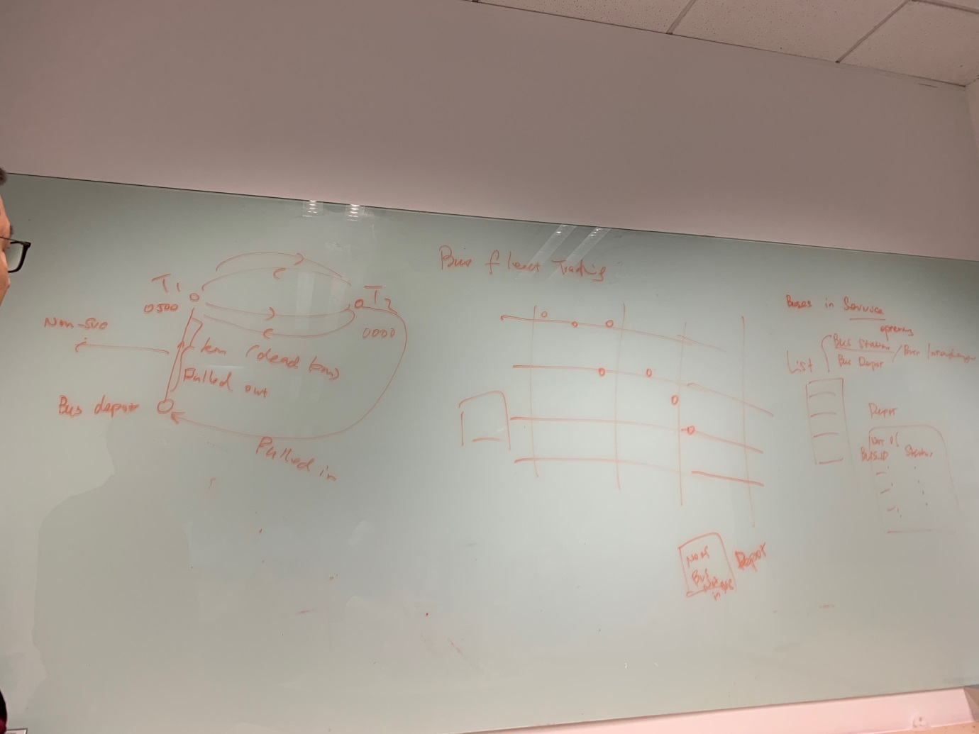

1. Buses in service (Operating)
2. Non service trip (Depot to bus terminus or bus stops)
3. Non service (No revenue)

* Pulled out from Depot to Interchange
* Pulled in Interchange to Depot

1. Buses information
   * In Interchange
   * In Depot
2. Bus Depot
   * Bus no
   * Maintenance / service / fuel filling
   * No of depot

# Dashboard Passenger

* Arrival / Estimated / Delay time
* Boarding / Alighting Passengers
* Frequency of Bus
* Bus Type

# Dashboard Buses

* Bus Types
* Bus Service Types
* No of Trips – per hour / per day

